Investigating Knowledge Distillation of BERT Models on Sentiment Classification Tasks

Abstract
Recent advances in neural network model compression have highlighted the efficacy of knowledge distillation (KD), where a smaller student model learns to mimic a larger teacher model. Building on the state-of-the-art KD methodologies, our work introduces a novel approach to refining the distillation mechanism within the KD framework for transformers. Specifically, we try to incorporate an attention mechanism in distilling knowledge from the teacher’s layers to the student’s. Moreover, we implement a regularization strategy to achieve sparsity in attention values, thereby enhancing the distillation efficiency. Additionally, we adapt a dynamic loss weighting mechanism from, which adjusts the weight of layer-wise distillation loss based on the student's performance. This adaptive weighting reduces the influence of layer distillation allowing the student to transition towards more autonomous learning phases after acquiring foundational knowledge from the teacher. Using our technique, we distill the 12-layer BERT model to a 4-layer version, and evaluate performance on a GLUE task – SST-2 sentiment classification. Our results show that the attention mechanism proves to be effective at building on the problems of past approaches and offers a considerable improvement.

Introduction
In the rapidly evolving field of deep learning, the surge in model complexity has significantly enhanced performance across various domains, including natural language processing (NLP) and computer vision (CV). Transformers [1], notable for their self-attention mechanism, have become pivotal in pushing the frontiers of NLP applications like translation, question-answering, and text generation. However, the very architectural innovations that make transformers powerful also make them resource-intensive, posing deployment challenges in resource-constrained environments. This necessitates the development of effective model compression techniques to bridge the gap between computational affordability and model performance.
Among the prevalent model compression strategies—knowledge distillation, pruning, and quantization—our research focuses primarily on knowledge distillation (KD) [2] [3]. Knowledge distillation, in particular, has emerged as a promising method for model compression by transferring knowledge from a "teacher" model to a "student" model.
In compressing models like those in the BERT family, an examination of different distillation strategies reveals the benefits of hint-based KD methods over traditional logits-only approaches [4]. By relaying information from intermediate layers of the teacher to the student model, hint-based methods facilitate a smoother learning process and typically lead to superior outcomes. However, this technique often necessitates precise alignment of layers between the teacher and student models, which can be complex.
When we want to utilize ‘hints’ from the intermediate layers of the teacher to distill knowledge to the student, we are forced to select a subset of m out of n teacher layers (where m is the number of student layers) to distill knowledge from. This inherent nature of the relationship between teacher and student models means that we have to face 2 problems, which are well-defined in the literature as the skip and search problems. The skip problem arises when there is a misalignment in the architecture between the teacher and student models, particularly when their layers do not correspond directly one-to-one. Traditional distillation methods often respond to this challenge by skipping certain teacher layers entirely during the distillation process, which can result in a loss of potentially valuable information that could aid the student model's learning process.
The search problem relates to identifying which layers of the teacher model should be used for distillation to maximize the student model's performance. The complexity of this problem increases with the depth and complexity of the network architectures involved. Finding the optimal layers or combinations of layers from which to distill knowledge involves a computationally intensive search, which can be impractical in many scenarios, especially when resources are limited.
In our work, we look to build upon the state-of-the-art when it comes to hint-based KD methods by further improving the mechanism by which layers are aligned between the student and the teacher and by ensuring that the student model remains adaptable and capable of learning beyond the initial phases of training.

Background and Related Works
Our work is informed by several foundational studies that have explored various strategies to optimize the knowledge transfer mechanism between layers in transformers.
The basic working of a transformer [1] is essential to our approach. It comes from using a type of similarity function between the query vector and the i-th input sequence to calculate the i-th attention score. Then this is normalized using softmax and the final output is a weighted sum of these attention score with the values
$Y = \sum_{i = 1}^{n}{}α_{i}*ν_{i}$
We make our way to the actual problem in steps, one of the initial points for our topic being the Patient Distillation loss [5], where A() is the alignment function to make a correspondence between the teacher and student layers. What it means to compare the layers is to compute the norm of the normalized differences between the teacher and student outputs at a particular layer and sum it for all layers we chose to ‘compare’. However, this work remained prone to the skip and search problems.
$L_{P}= -\sum_{i = 1}^{N}{}\sum_{j = 1}^{m}{}(||\frac{{h^{i,j}}_{S}}{||{h^{i,j}}_{S}||_{2}}-\frac{A(j)^{i}}{||A(j)^{i}||_{2}}{||}_{2})^{2}$
Combinatorial knowledge distillation [6] proposed an alternative to this: to combine the teacher layers into a group to be compared with the student layer, which are then concatenated by F_c, while F_r handles any dimensionality mismatch using a single projection layer. This was done with the intent to solve the problem of having to depend on the alignment function to hopefully make the best possible combinations.
${C^{j}}_{h}= F_{c}({h^{k}}_{T}); {h^{k}}_{T }∈ A(j)$
$C^{j} = F_{r}({C^{j}}_{h})$
$∪A(j) = \{{h^{1}}_{T} , ... , {h^{n}}_{T}\}$
To resolve the randomness introduced by arbitrarily grouping teacher layers together, it is proposed to use all layers/buckets together.
Given that we are dealing with distilling a transformer to a transformer, research suggests that linguistic patterns can be captured by the attention probabilities in transformer models [7]. This means that we can minimize the self-attention divergence between the student and the teacher as a means of ensuring that the teacher’s linguistic behavior can be preserved in the student. To this end, we can then calculate the KL-loss between the self-attention matrices for the student and the teacher [7].
$A = softmax(d_{a}QK^{T})$
$L_{KLT}= \frac{1}{L} \sum_{i}^{L}{}A_{T_{i}}log\frac{A_{T_{i}}}{A_{S_{i}}}$,
where L where L is the length of a sequence, A_T_i and A_S_i are the i-th row of the self-attention matrix for the teacher and student.
Finally, to ensure the student model remains capable of learning beyond the initial phases of training, we look towards work done on vision transformers [8]. During the training process, Zhou. et al suggest gradually decaying the weight of their channel distillation loss. A gradual decay is chosen because neural nets inherently respond better to soft changes rather than hard changes. The purpose is to enable the student to gradually control the optimization rather than the teacher. They justify this decision based on experimental analysis that showed that after a certain number of epochs, cross entropy loss (CE(s, y)) starts to reverseley rise. This indicates that the teacher is now inhibiting the student from learning.
$E(γ) = γ * λ^{\frac{n_{e}}{n}}$ ,
where gamma is the initial weight of distillation loss, and λ is a constant coefficient, and n_e denotes n’th epoch in the entire training process, and n is an empirical value representing the number of epochs we reduce our weight of loss
We investigate whether this approach can be extended to NLP tasks and whether the nature of the rise in student CE is something that is inherent to CNNs.

Methodology
The student and the teacher model in our model have layers 4 and 12 respectively with the remaining details given. We denote the second student layer with S_2 and the 9th teacher layer with T_9. As seen in the related work part, several approaches have been used to map the intermediate layers between the student and the teacher.
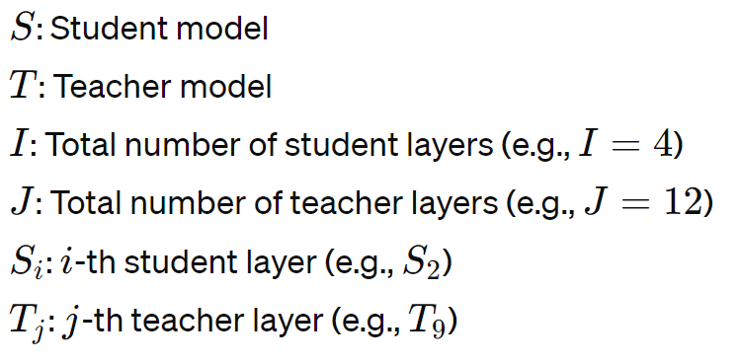
Our approach uses a measure of similarity better known as attention [1] to select which teacher layers hold more importance for each student layer. The loss function’s component related to attention is focused towards those layers that hold more importance. Importance is defined by the normalized attention value of that teacher layer with the corresponding student layer.
To define some notation: alpha_i,j is the attention weighted on the i-th student layer and the j-th teacher layer such that summing over all the teachers (all the j_s) would result in one for any given i (student layer) because of the softmax function.
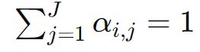
L_i is the weighted sum if we use the alpha_j to weigh all the teacher layers' hidden states corresponding to any student layer. So if we have a vector of 12 teacher layers and a vector of 12 alphas 1_j , the weighted hidden layer L_i is simply the dot product of the two vectors.
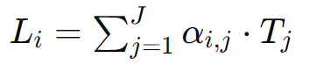
Each L_i represents the state we want S_i to be in and therefore we use the Mean Square Error Loss to compare the two attributes. More formally L_i = alpha-i,1 * T_1 + alpha_i,2 * T_2 .. where the index sums over all teacher layers j=1 to J. The mean square error for each batch is averaged over n number of student layers.
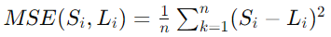
It is worthy to note that at any given loss backward propagation L_i would be different (because the weights would be updates). This implies that the new attention weights are different and therefore the state we want to be in: L_i is also always changing. This change allows each layer to learn from some teacher layers without any sort of explicit mapping. This addresses both the skip and search problems mentioned earlier, allowing our model the leeway to learn from the layer most similar.
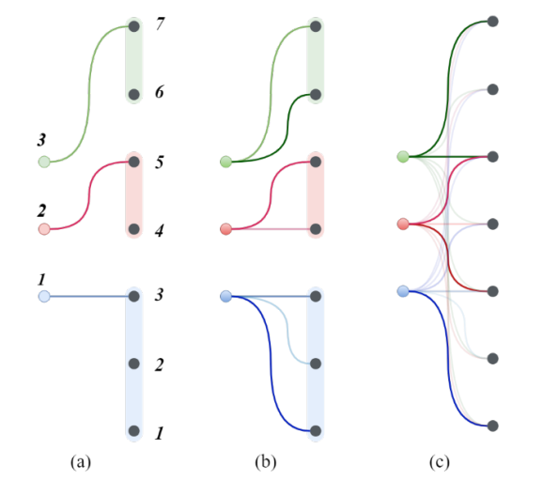
Figure 1 [9]
Figure 1 demonstrates the track we are treading where any student layer will have J attention weights where J is the number of teacher layers.

Experimental Study
In our study, we narrow our focus to the SST-2 dataset, a subset of the GLUE benchmark, for evaluating KD techniques in the realm of NLP. Unlike some traditional approaches where a pre-trained student model is utilized, we opt to train the student model from scratch rather than initializing it with pre-existing parameters. This choice allows us to closely examine the efficacy of our proposed KD technique in training the student model independently, starting from random initialization and allows us to tailor the architecture and learning process to the specific nuances of our dataset. Our approach of training from scratch allows for the exploration of new model architectures that are not bound by the constraints of existing pre-trained models in popular pieces of literature which is key in cutting-edge research areas such as artificial intelligence.

Model | # Layers | # Params | Acc.
Teacher Model | 12 | 110 M | 92.43%
Student (Logits Distillation) | 4 | 24 M | 78%
Student (Combinatorial Layer Distillation) | 4 | 24 M | 80%
Student (Combinatorial Layer Distillation w. Decay) | 4 | 24 M | 79%
Student (Attention Based Layer Distillation w. Decay) | 4 | 24 M | 81%
Figure 2

We chose SST-2 in order to develop our model on a dataset fundamental to NLP tasks. Working with such a dataset allows our technique to generalize to more difficult tasks present in the field of NLP such as machine translation, document summarization, and question answering. Through rigorous training and experimentation, we seek to ascertain the effectiveness of our approach in distilling knowledge from the teacher to the student solely based on their performance on SST-2. This focused approach enables us to gain insights into the performance and behavior of our technique in a controlled setting, shedding light on its potential applications and limitations in sentiment analysis tasks.
A noteworthy point in our study is the size of our student model: which is less than a quarter of the teacher and less than a half compared to other popular literature, in terms of the number of parameters. Popular pieces of literature have struggled to compress their network further than half and we, despite starting from random weights, have been able to compress our student considerably more.
To provide readers with a deeper understanding of fine-tuning concepts, we reference the work of Devlin et al. for comprehensive insights. Our experimental setup follows a fine-tuning pipeline similar to prior works, ensuring consistency and comparability.

Analysis
Our results are mainly in line with our hypotheses for each type of distillation. While viewing the results, it is important to understand that our student model’s configuration varies significantly from the literature. While it is also a 4-layer BERT model, it is 79% smaller than our teacher. This is due to the fact that we configured the model to have a smaller hidden and intermediate size. This helped us with 2 things: it helped significantly reduce run-time and iterate faster as we were computationally limited, and it also acts as a regularizing technique in comparison to larger student models by inherently restricting the amount of knowledge that the teacher can distill to the student, forcing it to focus only on the most salient features by avoiding over-parameterization.
When we analyze the results that our attention model obtained, we can see that it shows an improvement over the combinatorial approach. This means that our attempt at solving the search and skip problems proved to be successful. While on 10 epochs, the difference in accuracy may seem insignificant it is important to note that the attention mechanism shows much sharper descending loss curves for training. This implies that on further training it would be fair to expect that the attention mechanism leads to a further increase in accuracy.
One contradiction that we see is in the performance of our exponential decay function attached to layer loss. We can conclude from this that even though literature suggests that decaying layer loss weightage proves to be effective when dealing with vision-transformers, this does not necessarily mean that that effectiveness extends to the domain of NLP tasks. This can mainly be attributed to the difference in the nature of features that have to be learned in both cases. However, it is also important to note that our testing in terms of finding the best hyperparameters for the layer loss was not exhaustive due to computational limitations. So, while unlikely, the possibility that better hyperparameters exist which allow for the exponential decay to prove efficacious does exist. This is something that could be further investigated in future works.
There is an obvious tradeoff between computational efficiency and accuracy but achieving a high magnitude for accuracy values was not the goal of this study to begin with. Our results prove that the attention mechanism contributes to a better performance when it comes to the process of distillation in itself. Our approach of training rather than fine-tuning also helps us maintain generalizability in our students and prevents overfitting by not choosing to go with a pre-trained student.

Future Work
Knowledge distillation techniques have also been combined with other deep learning models for specific use cases. One such study presented by Matthew Hutter[11] models LLVC for real-time any to one voice conversation combines knowledge distillation with generative adversarial architecture to achieve their 2.8x speed. This shows that all efforts in the domain of knowledge distillation are not independent of other branches in deep learning, but rather knowledge distillation allows for complex ideas to be implemented in real life. Following the topic of complex efforts, a research paper by Alex Wilf[10] employs the technique of projecting our problem to a higher dimension in order to take its difference and then use KL-Divergence to match teacher and student differences.
These researches along with several others in and beyond the field of knowledge distillation make use of this technique to their respective purposes. With respect to our specific implementation, we see applications in nearly every field involving choice. Choices are an essential part of deep learning either in the form of initialization or hyperparameters or anything else. The concept of attention extends to beyond simple ideas, and we believe involving it in the field of knowledge distillation has opened a door for endless possibilities. The idea we present is complex yet simple in an intuitive sense. Who can better decide than math itself. Works relating knowledge distillation have been even extended to 3D and this approach is capable of opening up many more dimensions.

Appendix
- Dataset Details
We use the Stanford Sentiment Treebank v2 (SST-2). It is built for a sentiment classification task of classifying long movie reviews into positive and negative classes. We load our dataset directly from HuggingFace. The train data has 67.3k rows and the test data has 1.82k rows. It consists of 11,855 single sentences extracted from movie reviews. It was parsed with the Stanford parser and includes a total of 215,154 unique phrases from those parse trees, each annotated by 3 human judges. To view more details about the dataset, please access it here.
- Student Model Configuration
Our student model is a 4-layer version of BERT with a hidden layer size of 540 and an intermediate size of 500. We set our max token length for the tokenizer to 64 as per literature, and we use a pre-trained TextAttack tokenizer directly from HuggingFace.
- Teacher Model Configuration
We use a standard uncased BERT-base model as our teacher that is pre-trained for SST-2 using TextAttack.
- Hyperparameters
We train all student models from scratch on 10 epochs, intentionally not choosing the fine-tuning route. We choose 10 epochs due to computational limitations. 10 epochs seemed to be an appropriate number to allow us to gauge the performance of our distillation methods. The hyperparameters we used for each distillation type are as follows:
Simple Logits Distillation
Learning Rate = 2e-5, T = 2, ɑ = 0.5
Combinatorial Layer Distillation
Learning Rate = 1e-5, T = 5, ɑ = 0.2, β = 0.5, 𝝲 = 0.1
Combinatorial Layer Distillation with Decay
Learning Rate = 1e-5, T = 3, ɑ = 0.5, β = 0.5, 𝝲 = 0.1, 𝝀 = 0.9
Attention Based Layer Distillation with Decay
Learning Rate = 2e-5, T = 3, ɑ = 0.4, β = 0.5, 𝝀 = 0.8, Number of Attention Heads = 1

References
[1] A. Vaswani et al. Attention is all you need. Advances in neural information processing systems, 2017
[2] G. Hinton et al. Distilling the knowledge in a neural network. arXiv, 2015.
[3] A. Romero et al. Fitnets: Hints for thin deep nets. arXiv, 2014.
[4] Y. Tang et al. A Survey on Transformer Compression. arXiv, 2024
[5] S. Sun et al. Patient Knowledge Distillation for BERT Model Compression. Proceedings of the 2019 Conference on Empirical Methods in Natural Language Processing
[6] Y. Wu et al. Why skip if you can combine: A simple knowledge distillation technique for intermediate layers. Proceedings of the 2020 Conference on Empirical Methods in Natural Language Processing (EMNLP).
[7] M. Ji et al. Show, Attend and Distill:Knowledge Distillation via Attention-based Feature Matching. arXiv, 2021
[8] Z. Zhou et al. Channel Distillation: Channel-Wise Attention for Knowledge Distillation. arXiv, 2020
[9] P. Passban et al. ALP-KD: Attention-Based Layer Projection for Knowledge Distillation, arXiv, 2021
[10] A. Wilf et al., Comparative Knowledge Distillation, Carnegie Mellon University, 2023.
[11] K.Sadov et al. Low-latency Real-time Voice Conversion on CPU

